Requirements for the formalization of abstract materials
Dear conference participants!
The book of abstracts will be published in electronic form only with assignment of the ISBN index. The printed version of the book is not provided.
Materials for publication (abstracts of plenary and oral reports, as well as bench messages), formalized in accordance with the rules (see below) should be sent to the conference address OCBT2020@urfu.ru
The volume of abstracts should not be exceeded 2 pages, strongly preferable 1 page of the machine-type text. The abstracts of the reports are taken by English.
Materials that do not satisfy the requirements for the design will not be considered.
RULES FOR THE DESIGN OF MATERIALS
The abstracts of the report should be carefully edited and read by the authors. The volume of text made in the editor MS Word in the edit of the Times New Roman, Size - 14, through the interval of 1,15 (use the multiplier), fields from all sides 2 cm, Fatio A4 (21 cm × 29,7 cm).

- File name: Surname_N.P.doc.
- Text editor – Microsoft Word.
- File format – doc or docx.
- Then Authors, Font size 14
- Name of the university (organisation) (italic), index, address (italic), E-mail of author for correspondence (italic), Font size 14.
- After empty string – keywords – up to 5 words.
- After empty strings – The main text (Actional indent 1,25, Font size 14), Alignment by width.
- References list if any, font size 12.
- Tables, drawings (colored and h / b) and graphs are allowed. Formulas must be drafted (not to insert as a picture!).
- If the drawings and tables are greater than one − they are numbered, Names (editable) of drawings and tables – in the center, text and numerical values are in the tables (Font size 12) should be editable (not to put id as a picture!); explanatory picture caption should be editable (Font size 12). The inscriptions built into the drawings must be carefully edited, correspond to the drawing and text of the abstracts of the reports.
- Don't enumerate pages of the abstract.
- All drawings, tables and formulas in the text should have links.
- For page - below, sign © Surname, initials of authors, year, 2019; Font size 10.
- If the work is done with financial support, this information is indicated on the first page - below, * the work is done with the support of the grant #, the font size 10.

Articles are published in the author's version, the editorial board reserves the right to correct rough errors, typing errors and inaccuracies. By sending the text of the article, the author assumes the obligation that the text of the article is the final option, contains reliable information relating to the results of the study, and does not require the finalization.

An example of abstract presentation is given below.
Respectfully,
Conference Organizing Committee

T.A. Kalinina, A.A. Vysokova ¹,
Lukyanina N.V.¹, Z.-J. Fan ³,
T.V. Gluhareva ^{1,2}

¹Ural Federal University, 28 Mira St., Russia, Yekaterinburg, 620078,
t.v.glukhareva@urfu.ru,
²Ural Branch of Russian Academy of Sciences
I.Ya. Postovsky Institute of Organic Synthesis, 22 S. Kovalevskoi St., Russia, Yekaterinburg, 620137
³State Laboratory of Organoelemental Chemistry,
Nankai University,
300071, China, Tianjin, St. Veyjin, 94,
zjfan@nankai.cn

study of 1,2,3-selenodiazolyl-4-UreaS as plant systemic resistance inductors *

Keywords: elicitors, systemic acquired resistance, inductors of SAR, 1,2,3-selenodiazole.

A large loss of cropping agricultural plants is mainly associated with fungal and bacterial diseases plants. Viral diseases of plants are commonly widely, but at the same time are more dangerous. This is due to the fact that viruses completely affect the vascular system of plants and effective pesticides for their treatment practically do not exist [1].
We have been obtained structural analogues of synthetic activators of SAR, Thiadinyl and methiadinyl, 1,2,3-selenodiazolylurea derivatives 1 a-m using the method developed by us earlier [2].

* The work was supported by the RSF Grant 16-16-04022.
© Kalinina T.A., Vysokova A.A., Lukyanina N.V., Fan Z.-J., Gluhareva T.V., 2019
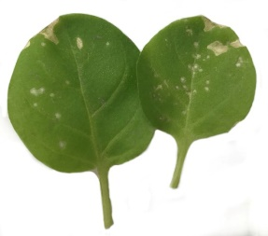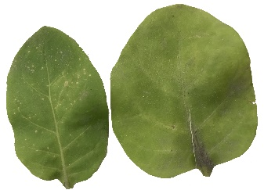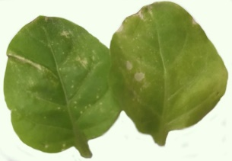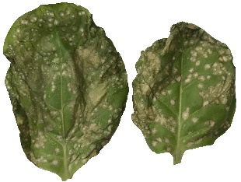
1k 1l TDL water
Figure 1. Tobacco leaves treated with 1k, 1l, TDL and water
Continued text of the published material ... (Table 1).
Table 1
Properties of samples
Properties | Samples
 | Sample №1 | Sample №2 | Sample №3
Length of the sample, сm | 55 | 66 | 77
Elongation, mm | 12 | 23 | 34
Thus, during the experiment ...
References
- Tennant P., G’bba A., Roye M., Fermin G. Viruses: Molecular Biology // Host Interactions, and Applications to Biotechnology. P. 135-156 (2018).
- Huang H.-C., Wu M.-T. // Plant Pathology Bulletin. 2009. Vol. 18, P. 1-12.
- Das S. K. // J. of Atoms and Molecules. 2014. Vol. 4. P. 45–51.
- Y. Bektas, Eulgem T. // Frontiers in plant science. 2014. Bol. 5. P.1–17.
- Kessmann H., Staub T., Ligon J., Oostendorp M., Ryals J. // European J. of Plant Pathology 100. 1994. P. 359–369.
- Zine H., Rifai L. A., Faize M., Bentiss F., Guesmi S., Laachir A., Smaili A., Makroum K., Sahibed-dine A., Koussa T. // J. of Agricultural and Food Chemistry. 2016. Vol. 64. P. 2661 – 2667.
- Sakurai S., Ohara T., Morimoto M., Kondo N., Ikishima H. WO Patent No. 2015/141867 (24 September 2015).
- Fan Zh.-J., Shi Z., Zhang H., Liu X., Bao L., Ma L., Zuo X., Zheng Q., Mi N. // J. of Agricultural and Food Chemistry. 2009. Vol. 57. P. 4279–4286.
- Kalinina T. A., Shakhmina Y. S., Glukhareva T. V., Morzherin Y. Y., Fan Z.-J., Borzenkova R. A., Skolobanova E. S., Kiseleva I. S. // J. of Heterocyclic Compounds. 2014. Vol. 50. P. 1039–1046.

