T.A. Kalinina, A.A. Vysokova ¹,
Lukyanina N.V.¹, Z.-J. Fan ³,
T.V. Gluhareva ^{1,2}

¹Ural Federal University, 28 Mira St., Russia, Yekaterinburg, 620078,
t.v.glukhareva@urfu.ru,
²Ural Branch of Russian Academy of Sciences
I.Ya. Postovsky Institute of Organic Synthesis, 22 S. Kovalevskoi St., Russia, Yekaterinburg, 620137
³State Laboratory of Organoelemental Chemistry,
Nankai University,
300071, China, Tianjin, St. Veyjin, 94,
zjfan@nankai.cn

study of 1,2,3-selenodiazolyl-4-UreaS as plant systemic resistance inductors *

Keywords: elicitors, systemic acquired resistance, inductors of SAR, 1,2,3-selenodiazole.

A large loss of cropping agricultural plants is mainly associated with fungal and bacterial diseases plants. Viral diseases of plants are commonly widely, but at the same time are more dangerous. This is due to the fact that viruses completely affect the vascular system of plants and effective pesticides for their treatment practically do not exist [1].
We have been obtained structural analogues of synthetic activators of SAR, Thiadinyl and methiadinyl, 1,2,3-selenodiazolylurea derivatives 1 a-m using the method developed by us earlier [2].

* The work was supported by the RSF Grant 16-16-04022.
© Kalinina T.A., Vysokova A.A., Lukyanina N.V., Fan Z.-J., Gluhareva T.V., 2019
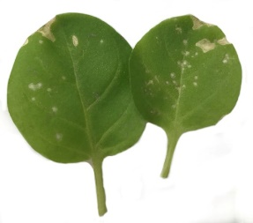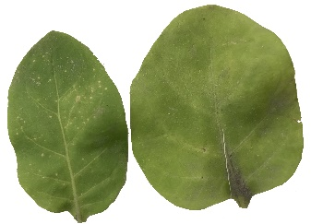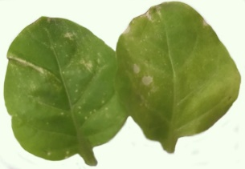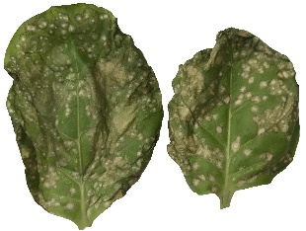
1k 1l TDL water
Figure 1. Tobacco leaves treated with 1k, 1l, TDL and water
Continued text of the published material ... (Table 1).
Table 1
Properties of samples
Properties | Samples
 | Sample №1 | Sample №2 | Sample №3
Length of the sample, сm | 55 | 66 | 77
Elongation, mm | 12 | 23 | 34
Thus, during the experiment ...
References
- Tennant P., G’bba A., Roye M., Fermin G. Viruses: Molecular Biology // Host Interactions, and Applications to Biotechnology. P. 135-156 (2018).
- Huang H.-C., Wu M.-T. // Plant Pathology Bulletin. 2009. Vol. 18, P. 1-12.
- Das S. K. // J. of Atoms and Molecules. 2014. Vol. 4. P. 45–51.
- Y. Bektas, Eulgem T. // Frontiers in plant science. 2014. Bol. 5. P.1–17.
- Kessmann H., Staub T., Ligon J., Oostendorp M., Ryals J. // European J. of Plant Pathology 100. 1994. P. 359–369.
- Zine H., Rifai L. A., Faize M., Bentiss F., Guesmi S., Laachir A., Smaili A., Makroum K., Sahibed-dine A., Koussa T. // J. of Agricultural and Food Chemistry. 2016. Vol. 64. P. 2661 – 2667.
- Sakurai S., Ohara T., Morimoto M., Kondo N., Ikishima H. WO Patent No. 2015/141867 (24 September 2015).
- Fan Zh.-J., Shi Z., Zhang H., Liu X., Bao L., Ma L., Zuo X., Zheng Q., Mi N. // J. of Agricultural and Food Chemistry. 2009. Vol. 57. P. 4279–4286.
- Kalinina T. A., Shakhmina Y. S., Glukhareva T. V., Morzherin Y. Y., Fan Z.-J., Borzenkova R. A., Skolobanova E. S., Kiseleva I. S. // J. of Heterocyclic Compounds. 2014. Vol. 50. P. 1039–1046.

